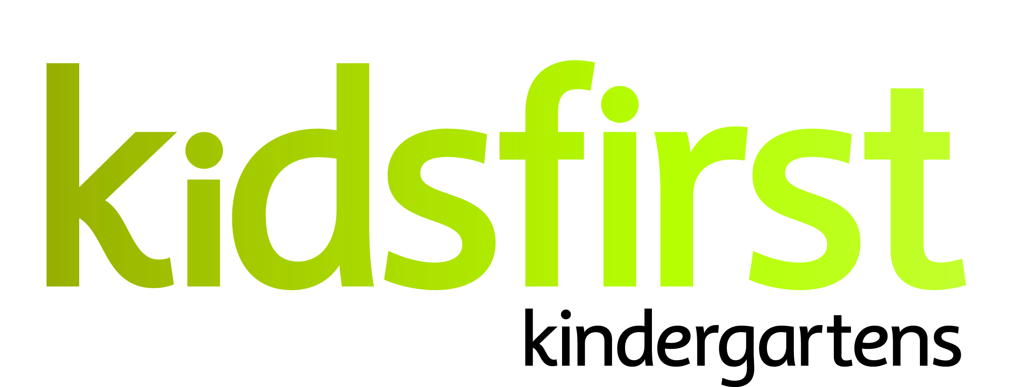

**PERSON SPECIFICATION**

**DATE:** May 2025

**POSITION:** Teacher 0.545(11:30 – 2:30 contact time)

**SERVICE:** Kidsfirst Kindergartens West Rolleston

**ADDRESS:** 78 Granite Drive, Newman Park, Rolleston

**PHONE NUMBER:** 021 682 344

**CURRENT OPERATING ROLL:** Full Day Kindergarten 8.30am - 2.30pm

Current roll 40. Open through school term breaks (Christmas Break excluded).

# **Description of and involvement in the community**

# Kidsfirst Kindergartens West Rolleston is a purpose-built sustainable building, which opened in 2017. It is situated within a subdivision in West Rolleston, an area still experiencing substantial growth.

Kidsfirst West Rolleston has a warm and bright inside environment offering a variety of spaces to support and encourage children's learning which is connected to outdoor space by a large, covered all-weather veranda. The playground offers a variety of flexible, adaptable, age-appropriate spaces – including the large sandpit which is hugely popular with all tamariki. The space available in this area creates lots of opportunities for various groups of children to use their imagination and test out their working theories independently or in collaboration with others.

Tamariki at Kidsfirst Kindergartens West Rolleston learn in an environment which values and supports uninterrupted and sustainable play. Tamariki develop working theories, social skills and communication, with support from the fully qualified and registered early childhood teaching team and are seen as confident and capable, risk takers and strategic thinkers. Links within the community are strong as are those within the kindergarten with whānau taking part in community events and fundraising opportunities.

**Curriculum Priorities**

* Whanaungatanga,
* Manaakitanga,
* Tiakitanga
* Ako

# **PERSON SPECIFICATIONS**

# **Personal Attributes that would best suit the needs of the kindergarten:**

* A committed partner to Te Tiriti o Waitangi with an understanding of bicultural practice and a commitment to their own continued growth in this area.
* The ability to establish strong professional, reciprocal relationships with whānau, children and the wider learning community, including external agencies as required.
* Excellent verbal and written communication skills and the ability to engage with a variety of audiences.
* An intentional kaiako with a proven approach to supporting tamariki learning outcomes and an excellent working knowledge of Te Whāriki.
* A kaiako with strengths in the principles of inclusion, social justice and who has a tamariki rights approach and knowledge about practicing tamariki agency within the programme.
* A kaiako who will be able to contribute to an internal evaluation process that critiques current practices and affects change that results in improved learning outcomes for tamariki.
* A kaiako who understands assessment for learning and has experience in applying this to support positive outcomes for tamariki.
* A kaiako who is energetic and enthusiastic. Someone who shows initiative, can articulate and listen to other points of view and can practice shared leadership within the team.