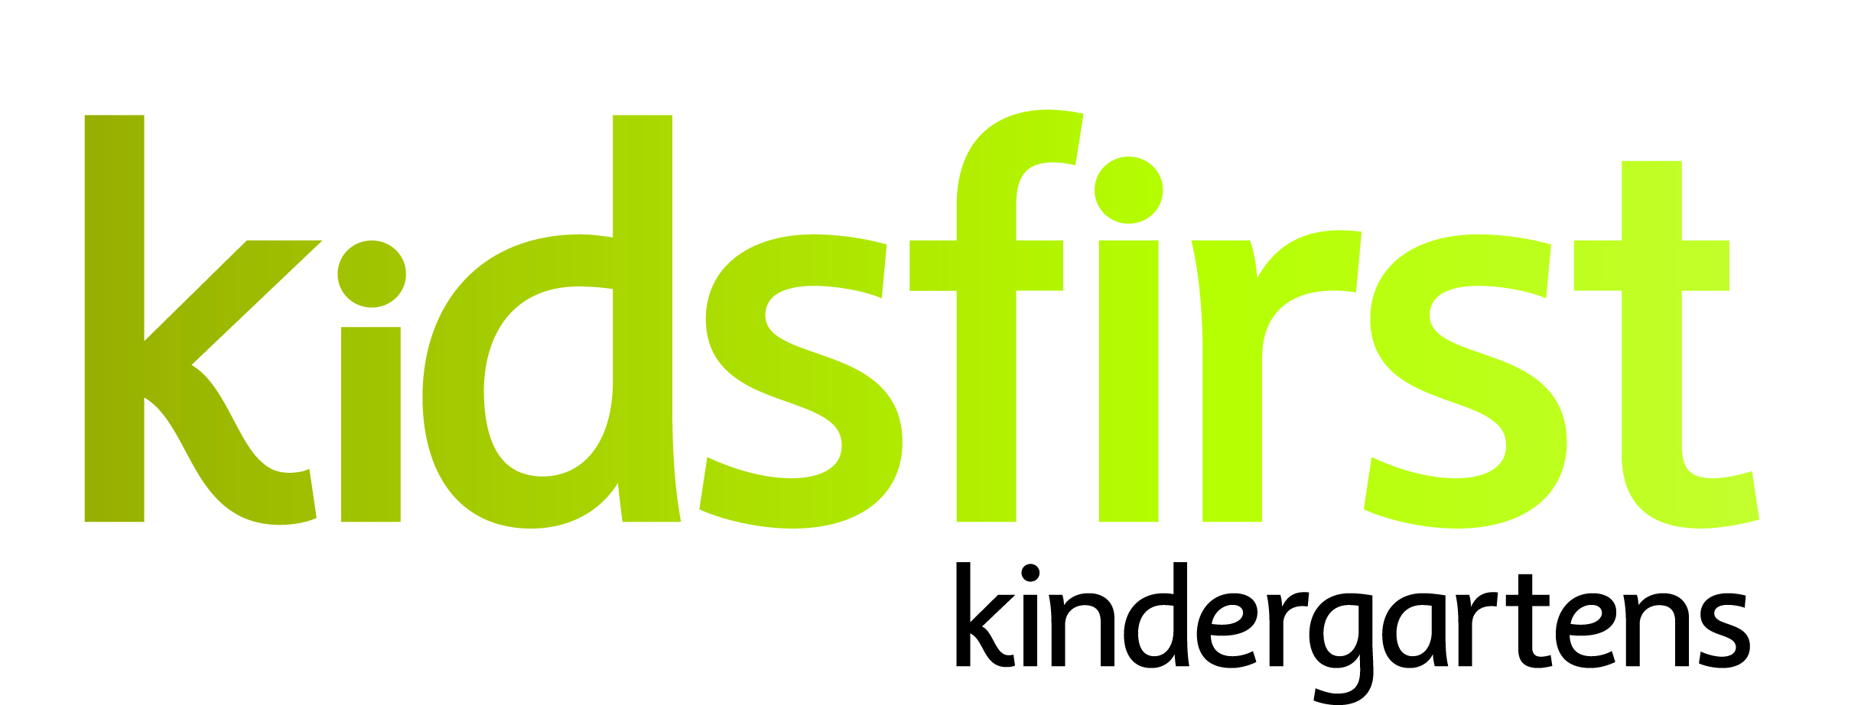

**PERSON SPECIFICATION**

**DATE:** May 2025

**POSITION:** Teacher 0.545(11:30 – 2:30 contact time)

**SERVICE:** Kidsfirst Kindergartens Ōpawa St Martins

**ADDRESS:** 8 Butler Street, Ōpawa, Christchurch

**PHONE NUMBER:** 021 764 872

**CURRENT OPERATING ROLL:** Full Day Kindergarten 8.30am - 2.30pm

Current roll 30:30

# **Description of and involvement in the community**

## Kidsfirst Kindergartens Ōpawa St Martins is in a quiet side street nestled within the loops of the Heathcote River and Hansen Park. The area is residential, both established and new housing, drawing from the immediate area and surrounding hills. A very ethnically diverse community, middle socio- economic area.

The kindergarten is well known and respected with many whānau spending time at the kindergarten. The kindergarten feeds about 5 local schools, state, integrated and private. The outdoor play space is well established with ample natural shade. There is an emphasis on learning in nature, going out into the community, creativity, and physical activity. This kindergarten was rebuilt in 2024 with a warm and bright indoor learning environment for Tamariki.

**Curriculum Priorities**

* Whanaungatanga- Community of Learners
* Tuakana Teina- Sharing Knowledge
* Whakapapa- Family links
* Taha Tinana- Physical Wellbeing and environment
* Manaakitanga- Welcoming and caring for others

# **PERSON SPECIFICATIONS**

# **Personal Attributes that would best suit the needs of the kindergarten:**

* A committed partner to Te Tiriti o Waitangi with a commitment to, and understanding of, bicultural practice including their continued growth in this area.
* The ability to establish strong professional, reciprocal relationships with whānau, children and the wider learning community, including external agencies as required.
* As a Kaiako in a point position starting at the kindergarten later in the session; they will need the ability to work as part of the team, engage themself into the programme straight away, with excellent communication both with verbal and written skills, shows initiative and can articulate and listen to other points of view.
* An intentional kaiako with a proven approach to supporting tamariki learning outcomes and an excellent working knowledge of Te Whāriki.
* A team and relationship focused kaiako who is creative, forward thinking, reflective and flexible in their approach. A wise, intentional practitioner – open, responsive, and reflective to new pedagogy.
* This kindergarten is involved in the Enviroschools programme with a commitment to education for environmental sustainability, it is important that the successful applicant has an awareness and understanding of the broader concepts of EfES
* A strength in the principles of inclusion, social justice and who has a tamariki rights approach and knowledge about practicing tamariki agency within the programme
* A kaiako who will be able to contribute to an internal evaluation process that critiques current practices and effects change that results in improved learning outcomes for tamariki.
* A kaiako who understands socio-cultural assessment for learning and has experience in applying this to support positive outcomes for tamariki.
* This position also has an element of non-contact time allocated to it.