PERSON SPECIFICATION 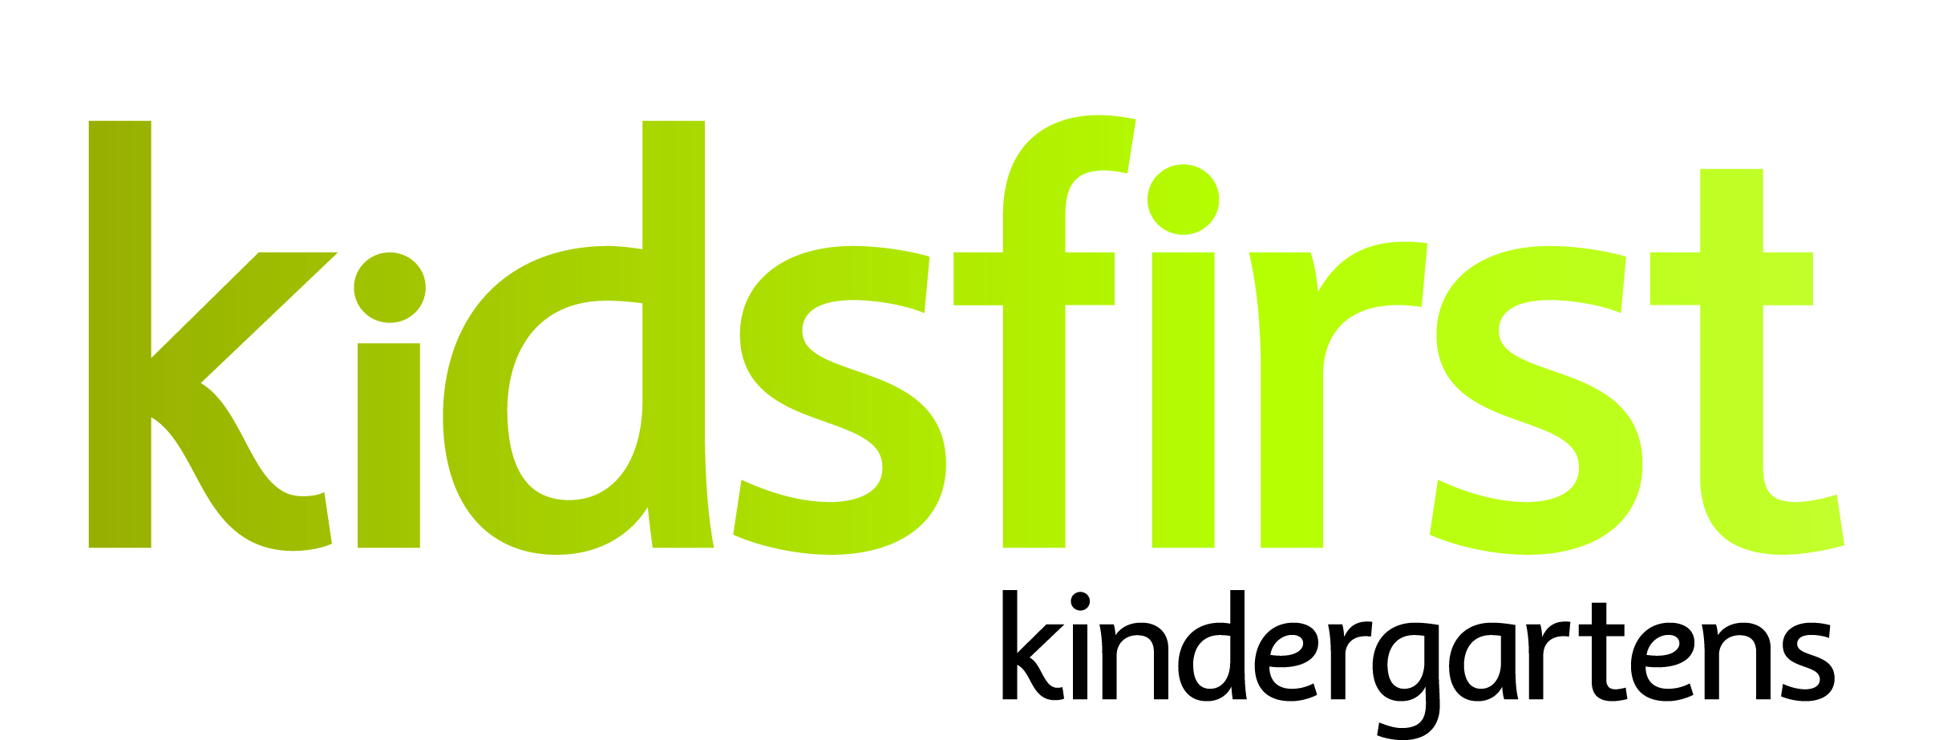

**DATE:** May 2025

**POSITION:** Teacher 0.545(11:30 – 2:30 contact time)

**SERVICE:** Kidsfirst Kindergartens Burnham

**ADDRESS:** 16 Ruru Street, Burnham Camp, Burnham

**PHONE NUMBER:** 021 740 629

**CURRENT OPERATING ROLL:** Full Day Kindergarten 8.30am - 2.30pm

Current roll 30:30

# **Description of and involvement in the community**

# Kidsfirst Kindergartens Burnham is situated in a quiet street alongside the Burnham Military Camp. There is a strong reciprocal relationship between the kindergarten and the Defence Force and a number of children attend this kindergarten from defence families, many of whom spend time serving overseas. The kindergarten also draws from the local farming community and the wider Rolleston area. This kindergarten is well supported by its whānau and local community, community events and fundraisers are well attended and are used to bring their community together.

Kidsfirst Kindergartens Burnham offer a variety of play spaces to support and encourage children's learning. The outdoor environment is well established with plenty of natural shade and provides opportunities for tamariki to challenge themselves physically, engage in risky play and explore the natural environment. There is an emphasis on learning in and exploring the natural world and children are encouraged to wonder about the world around them and to test out their working theories. In addition to the large outdoor space there is also a well-established forest garden that tamariki are involved in taking care of, supporting them to see themselves as kaitiaki of their space.

Tamariki at Kidsfirst Kindergartens Burnham are seen as competent and learn in an environment which values and supports uninterrupted and sustainable play. There is a seamless flow between the inside and outside environment and tamariki are supported to be curious, lead their own learning and make discoveries at their own pace.

**Curriculum Priorities**

* Whanaungatanga,
* Manaakitanga,
* Kaitiakitanga
* Ako

# **PERSON SPECIFICATIONS**

# **Personal Attributes that would best suit the needs of this kindergarten:**

* A committed partner to Te Tiriti o Waitangi with a commitment to, and understanding of, bicultural practice including their continued growth in this area.
* The ability to establish strong professional, reciprocal relationships with whānau, children and the wider learning community, including external agencies as required.
* Excellent verbal and written communication skills and the ability to engage with a variety of audiences.
* An intentional kaiako with a proven approach to supporting tamariki learning outcomes and an excellent working knowledge of Te Whāriki.
* A team and relationship focused kaiako who is creative, forward thinking, reflective and flexible in their approach. A wise, intentional practitioner – open, responsive and reflective to new pedagogy.
* A kaiako with skills in building relationships with whānau and within the local community.
* A kaiako with strengths in the principles of inclusion, social justice and who has a tamariki rights approach and knowledge about practicing tamariki agency within the programme.
* A kaiako who will be able to contribute to an internal evaluation process that critiques current practices and effects change that results in improved learning outcomes for tamariki.
* A kaiako who understands socio-cultural assessment for learning and has experience in applying this to support positive outcomes for tamariki.
* A kaiako who is energetic, enthusiastic, shows initiative and can articulate and listen to other points of view, who understands and can practice shared leadership within the team.