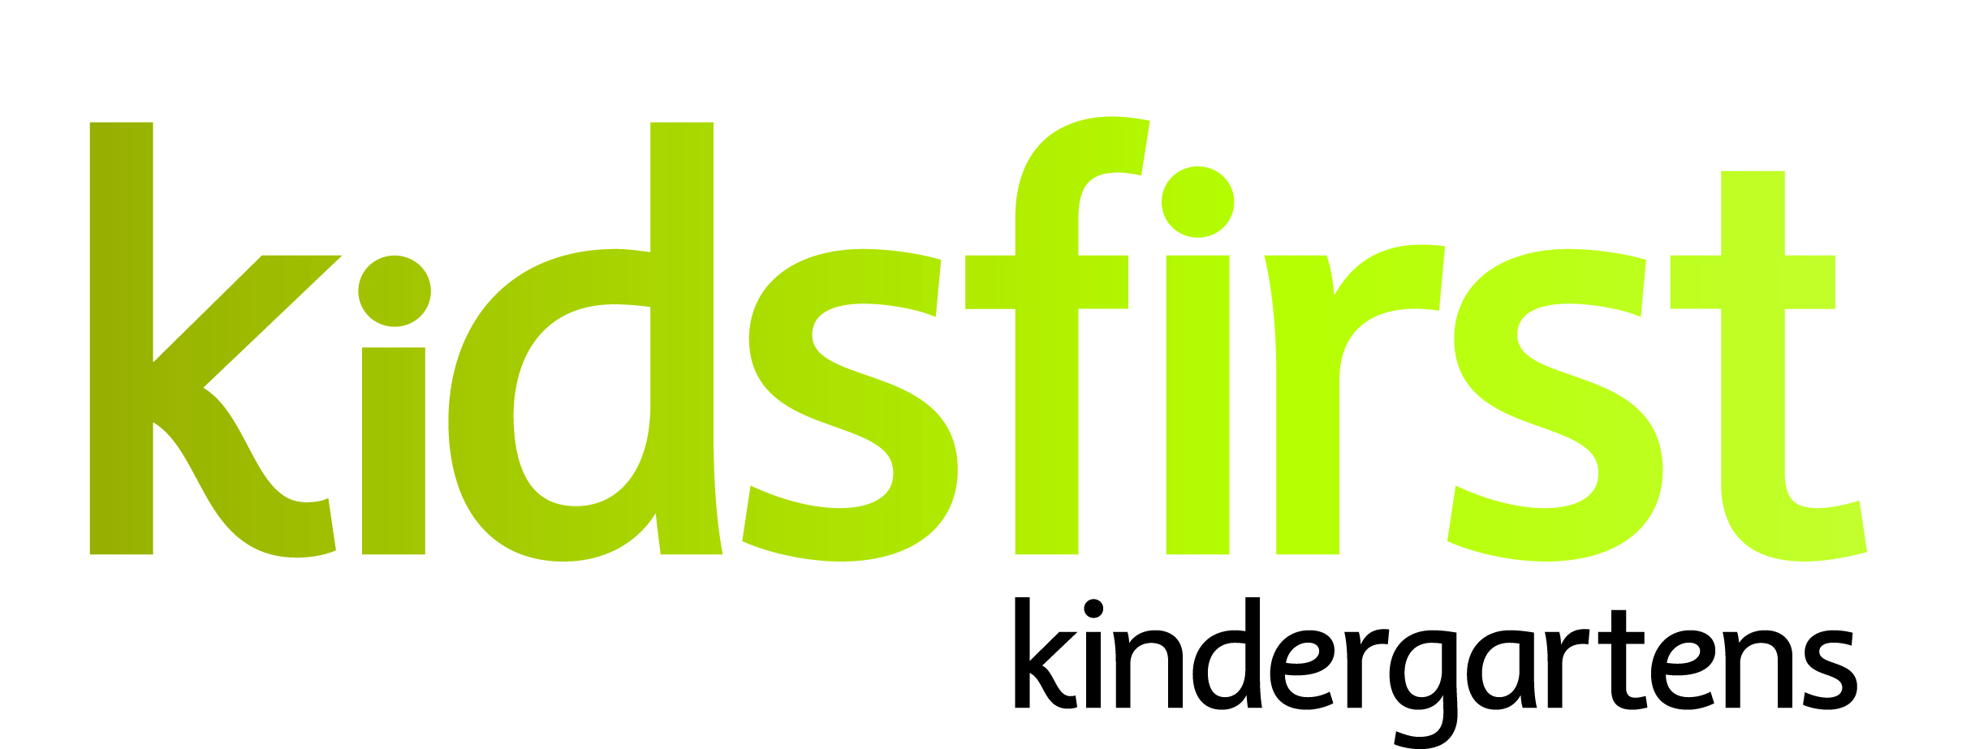

**POSITION and PERSON SPECIFICATION**

**DATE:** October 2024

**POSITION:** Kaiako Matua (full time)

**KINDERGARTEN:** Kidsfirst Kindergartens King Street

**ADDRESS:** 203 King Street, Rangiora

**CURRENT OPERATING ROLL:** Full Day Licensed Kindergarten 8.30am to 2.30pm

Monday- Friday (30/20)

Phone number 021972701

# **Description of and involvement in the community**

Kidsfirst Kindergarten King Street is one of 65 kindergartens operating under the Kidsfirst Kindergartens umbrella. With a rich history and strong ties to the Rangiora community and surrounding areas the Kaiako take immense pride in the kindergarten, its people, and the community they serve.

Renovated in 2017, the kindergarten features a bright, open-plan, and well-resourced indoor play area that allows for flexible use. The thoughtfully designed spaces encourage tamariki to engage in quiet, creative, imaginative play. The expansive backyard is a standout feature, complete with mature trees, gardens, a mud kitchen, sandpit, and equipment specifically designed to enhance tamariki exploration, physical growth, and development.

# **Curriculum Emphases**

# Whanaungatanga- nurturing connections

## Manaakitanga- we care about each other

* Kotahitanga-we are better together
* Whakaute- everybody is welcome here

# **Programme Priorities**

# **Community Connections**: prioritising inclusive relationships, actively engaging with the Peketeraki |Kahui Ako, participating in the Friends of the Family group, and fostering positive connections with local schools and external agencies.

# **Kaitiakitanga**: tamariki caring for the kindergarten, recognizing that their contributions are important and that the community views kindergarten as truly special place. They take pride in creating a tidy, well-resourced environment that reflects care and respect for Papatuānūku (Mother Earth).

## Ako: Fostering social competence alongside the acquisition of motor skills for tamariki is a feature. Intentional strategies to embrace these skills is learning that is valued here.

# **POSITION SPECIFICATIONS**

# **Kaiako Matua Leadership Requirements**

## The successful applicant will be a leader who;

* demonstrates strong pedagogical leadership and an ability to articulate, implement and reflect Kidsfirst Philosophy and values within the programme and kindergarten context
* inspires kaiako, building leadership capacity, and assisting team members to set and attain robust professional goals
* demonstrates an ability to provide ongoing critical feedback to kaiako in relation to teaching practices, building a culture of continual improvement
* effectively leads team dynamics, relationships and communication
* demonstrates a commitment to a Positive Behaviour Support framework and can lead this approach
* seeks and is responsive to professional feedback
* presents a professional demeanour with Kidsfirst colleagues and members of the learning community, engaging with the wider sector and portraying the Association positively within the kindergarten and in the wider community.

# **Curriculum and teaching requirements**

# The successful applicant will be an intentional kaiako who;

* demonstrates understanding of the theoretical underpinnings of Te Whāriki
* participates in ongoing and appropriate professional development that informs and is reflected in their practice
* participates in both child and kaiako initiated, sustained shared teaching episodes to extend tamariki thinking and value their contribution to the learning experience
* is committed to their own understanding as a Treaty partner demonstrated through professional growth and everyday practices within the kindergarten
* has a commitment to, and awareness of the principles of inclusion. This is evident in and integrated within their professional practice
* uses robust pedagogical documentation to support assessment, planning for learning and internal evaluation.

# **Relationships with tamariki**

## The successful applicant will:

* utilise a variety of methods to ensure the gathering of and responding to whānau aspirations for their tamariki
* value and respond to the social and cultural worlds and ways of learning of all tamariki
* provide feedback to tamariki that acknowledges their effort and success
* be available to tamariki so that they can revisit and share their learning with others
* engage in a pedagogy of listening to ensure tamariki are able to share their ideas and developing working theories.

# **Community requirements**

## The successful applicant will:

* have strong, responsive, reciprocal and respectful relationships with whānau, supporting tamariki sense of belonging
* ensure transitions are supported by effective partnerships between family/whānau, the kindergarten and schools
* promote and encourage active participation, involvement, and decision-making by the kindergarten community in all aspects of the teaching and learning programme and self-review
* play an advocacy role to support the child and the family/whānau, with a particular focus on inclusion.

**Working as part of a teaching team**

## The successful applicant will:

* have effective leadership around team dynamics, relationships, and communication
* inspire kaiako, build leadership capacity, and assist team members to set and attain professional goals
* seek and be responsive to professional feedback
* have strong collaborative relationships and professional communication with colleagues
* contribute to the team, providing an environment that reflects, and is responsive to the learners, whānau and wider learning community (people, places, and things, over time)
* lead an internal evaluation process that critically assesses current practices, gathers input from a wide range of sources, and implements changes to enhance learning outcomes for tamariki
* will be critically reflective about current theories and innovative in their practice, bringing a breadth of knowledge and experience that encompasses tamariki from two years of age to school entry.

# **PERSON SPECIFICATIONS**

# **Personal Attributes that would best suit the needs of the centre:**

* as the legacy of a Kaiako Matua who has served for 30 years concludes, the new leader must be dedicated to fostering relational trust and empathy as they re-establish as a new team.
* be able to communicate with care and consideration, to ensure change is evidence based and focused on improvement
* collaborate closely with the Education Team and Head Office personnel to ensure alignment and support
* in a busy and dynamic role, recognising and prioritising work effectively will be crucial.