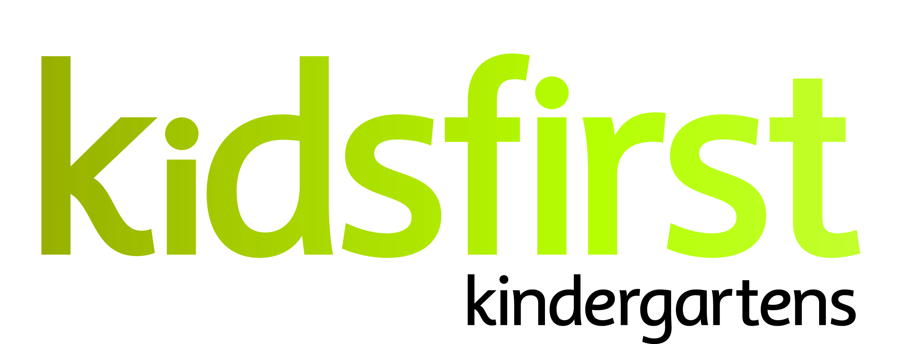

JOB DESCRIPTION and PERSON SPECIFICATION

DATE: March 2024

POSITION: Head Teacher (full time)

SERVICE: Kidsfirst Kindergartens Frankton

ADDRESS: 13 Robertson Street, Frankton, Queenstown

PHONE NUMBER: 03 442 2744

CURRENT OPERATING ROLL: Full Day Kindergarten 8.30am -2.30pm
Monday to Friday 30:30

Description of and involvement in the community

Kidfirst Kindergartens Frankton is one of seven kindergartens in Central Otago which operates under the umbrella of Kidsfirst Kindergartens. The Kindergarten is located at the base of the Remarkables in the heart of the Frankton community overlooking the Kawarau River and onwards to Lake Wakatipu. The setting is purpose built with a spacious indoor and two separate outdoor areas that invite inquiry and exploration. Kidsfirst Kindergartens Frankton provides care and education for up to 30 children each day from two to five years of age. Children from a wide geographical area and diverse nationality and cultural backgrounds attend the kindergarten.

Curriculum Priorities

Kidsfirst Kindergartens Frankton has undertaken a complex internal evaluation in recent years to review their curriculum priorities to ensure that these were in accordance with what learning matters to all members of the learning community. These are detailed as follows:
- Whanaungatanga (Relationships): with each other, tamariki, whānau, kaiako, the environment and the community. Whanaungatanga is the very essence of Kidsfirst Kindergartens Frankton.
- Child Agency (Rangitiratanga): This is seamlessly interwoven throughout the curriculum. Tamariki at Kidsfirst Kindergartens Frankton are empowered to drive their own learning and therefore hold a strong sense of belonging and ownership to their place.
- Ukaipōtanga: A place where one is nurtured and belongs.
- Manaakitanga: This encompasses caring attitudes, love, a willingness to support each other of the collective group. A warm, welcoming culture in which caring for others in both expected and encouraged.
- Taiao - Environment: A place where tamariki can challenge their physical skills, learn to take care of their place and the people, animals and things in it (kaitiakitanga).

POSITION SPECIFICATIONS

Head Teacher Leadership Requirements

The successful applicant will be a leader who;
- Demonstrates strong pedagogical leadership and an ability to articulate, implement and reflect Kidsfirst Philosophy and values within the programme and kindergarten context
- Inspires teachers, building leadership capacity, and assisting team members to develop, and progress, professional growth cycle goals and inquiries
- Demonstrates an ability to build a culture of continual improvement through leading and engaging in internal evaluation, both responsive and complex
- Effectively leads team dynamics, relationships and communication through building and fostering a culture of relational trust
- Attends to their own learning as a leader and also their own wellbeing, role-modelling this for their team
- Presents a professional demeanour with Kidsfirst colleagues and members of the learning community, engaging with the wider sector and portraying the Association positively within the kindergarten and in the wider community

Curriculum and teaching requirements

The successful applicant will be an intentional teacher who;
- Demonstrates understanding of the theoretical underpinnings of Te Whāriki and how this informs and guides the curriculum and teaching practices.
- Participates in ongoing and appropriate professional learning that informs and is reflected in their practice
- Participates in both child and teacher initiated, sustained shared teaching episodes to extend children’s thinking and value their contribution to the learning experience
- Is committed to their own understanding as a Treaty partner as demonstrated through professional growth and practice
- Has a commitment to and awareness of the principles of inclusion. This is evident in and integrated within their professional practice
- Uses robust documentation to support and inform assessment, planning for learning and internal evaluation

Relationships with children

The successful applicant will:
- Utilise a variety of methods to ensure the gathering of and responding to whānau aspirations for their children
- Acknowledge, value and respond to the social and cultural worlds and ways of learning of all children
- Provide feedback to children that acknowledges their effort and success
- Be available to children so that they can revisit and share their learning with others
- Engage in a pedagogy of listening to ensure tamariki are able to share and make sense of their ideas and developing working theories

Community requirements

The successful applicant will:
- Have strong, responsive, reciprocal and respectful relationships with whānau, supporting children’s sense of belonging
- Articulate and share the rationale for curriculum decisions with the kindergarten’s community of learners using methods that respect, acknowledge and are responsive to the diverse cultures and nationalities within this community
- Ensure transitions are supported by effective partnerships between whānau, the Kindergarten and local schools
- Promote and encourage active participation, involvement and decision-making by the kindergarten community in all aspects of the teaching and learning programme and internal evaluation
- Play an advocacy role to support the child and the whānau

PERSON SPECIFICATIONS

Personal Attributes that would best suit the needs of the kindergarten:
- The ability to establish strong professional, reciprocal relationships with whānau, children and the wider learning community. The successful head teacher will need to have a proven record in this area.
- The head teacher must have excellent verbal and written communication skills and be able to engage with a variety of audiences.
- The successful head teacher will need to be able to build and lead a collaborative teaching team across the whole kindergarten, so as to ensure a shared vision to meet the learning needs of this unique community
- To motivate and inspire the team to provide a wise programme that ensures positive learning outcomes for all children.
- The successful applicant will have a strong understanding and the ability to lead Planning for Learning and Internal Evaluation.
- To foster a sense of a community of learners with the local schools and other schools in the wider Frankton/Queenstown area.
- S/he will work in collaboration with the Education Team and Head Office personnel
- The head teacher will need to be enthusiastic about continuing learning for themselves and others and be innovative in their practice.
- The head teacher should have a proven record of successfully leading and inspiring a team through the use of effective communication strategies that encourages team cohesion and continuous improvement.
- As a head teacher the successful applicant will be critically reflective about current theories and innovative in his/her practice. S/he will have a breadth of knowledge and experience that includes children from 2 years to school entry.
- The head teacher will be a wise practitioner – open, responsive and reflective to new pedagogy.

