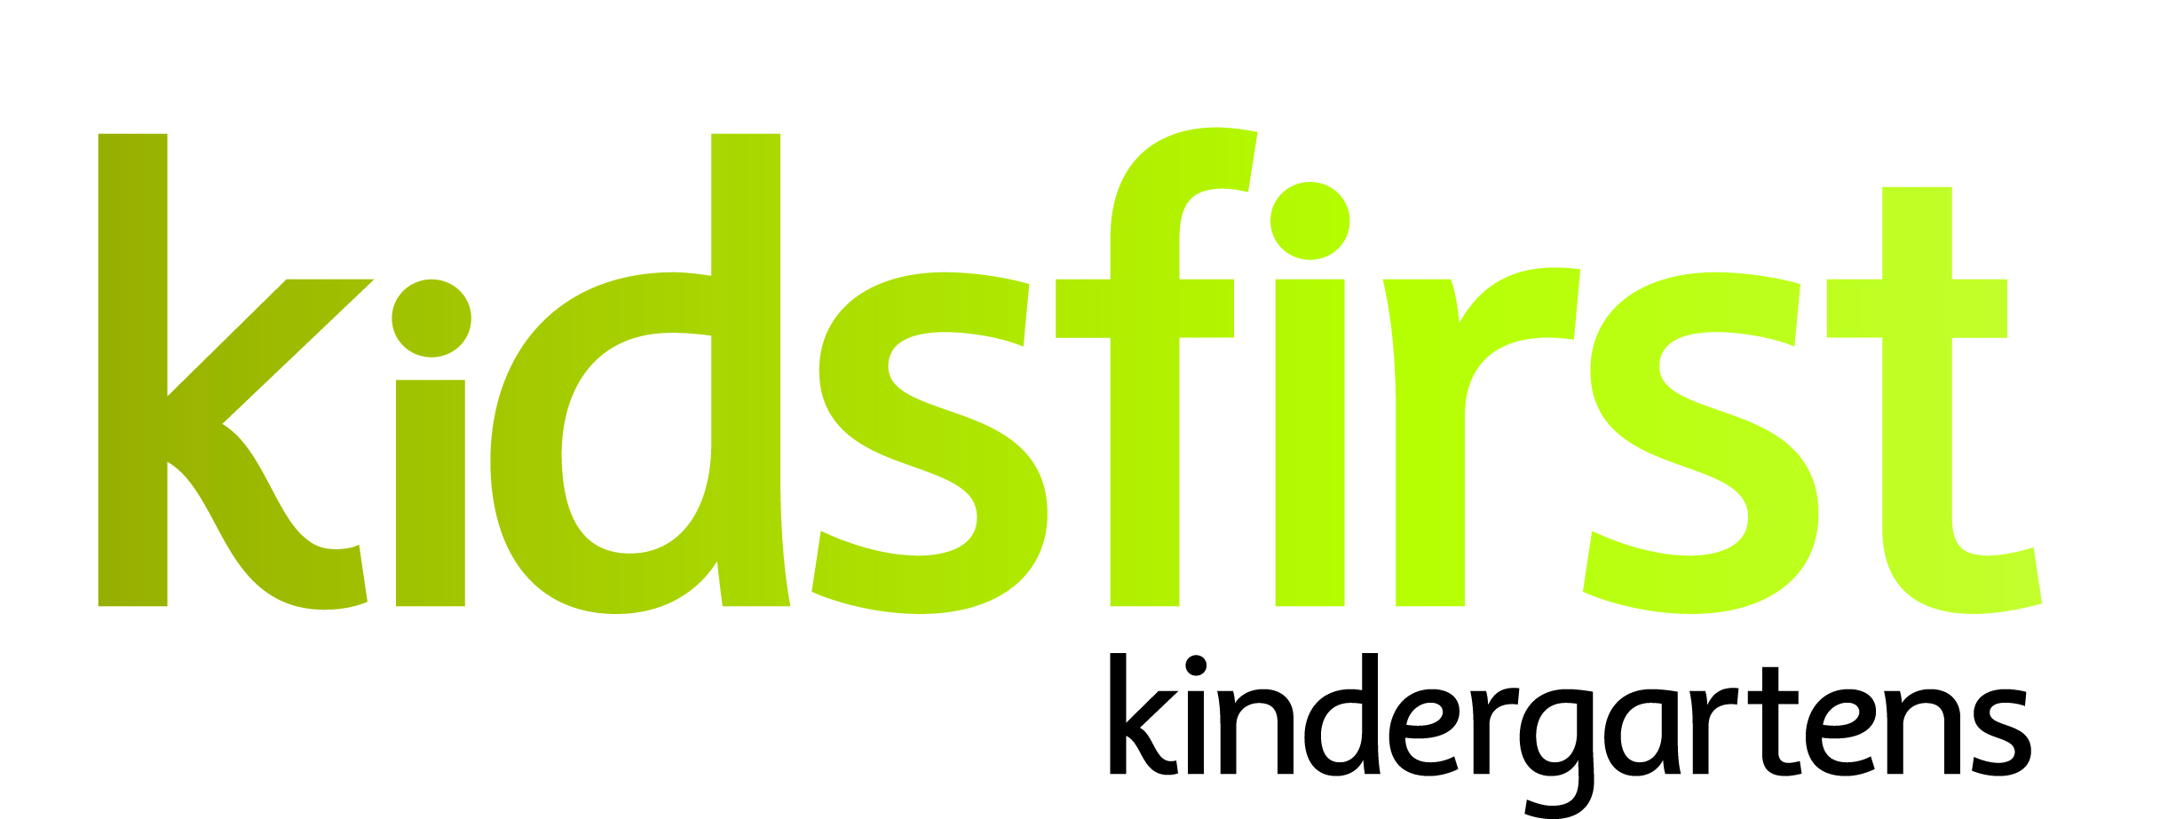

**POSITION and PERSON SPECIFICATION**

**DATE:** October 2024

**POSITION:** Head Teacher (full time)

**SERVICE:** Kidsfirst Kindergartens Avonhead

**ADDRESS:** 49 Staveley Street, Avonhead

**CURRENT OPERATING ROLL:** Full Day Kindergarten (8.30am to 2.30pm) 30/20

# **Description of and involvement in the community**

# Kidsfirst Kindergartens Avonhead is located next to the Staveley Reserve in the heart of the Avonhead community. The kindergartens ‘big backyard’ with mature trees and gardens features a range of fixed and moveable equipment, vegetable gardens, and has just completed a redevelopment of the sandpit area funded through successful grant applications.

Our vision is that we will ‘provide a warm welcoming environment for tamariki, whānau and community. We support and extend social competence and enquiring minds to encourage a thirst for lifelong learning.’

# **Curriculum Emphases**

# Our program for children aged 2 – 5 years places significance on our curriculum priorities,

# Ngā Hononga (Relationships)

# Te āheinga hapori (Social Competence)

# Hinengaro hinegaro (Inquiring minds)

# Mana reo (Communication)

# These are supported through ongoing engagement and development through the PBS program and internal evaluation.

# **Programme Priorities**

* Developing a sense of belonging for children, whānau and community
* Being an intentional/purposeful teacher
* Children’s growing understanding of social competence, respect for self and others, and taking responsibility within the programme.
* Building Tikanga Māori perspectives into the programme.
* Internal Evaluation will be in depth and inform teaching and learning practices.
* Enhancing the learning environment (both internal and external) through critical thought, wonderment, and inquiry.
* Promoting a calm, respectful, peaceful environment, and programme
* Supporting children’s developing understanding of social competence (teaching strategies)
* Building and maintaining professional network capabilities

# **POSITION SPECIFICATIONS**

# **Curriculum and teaching requirements**

# The successful applicant will be an intentional teacher who;

* Demonstrates understanding of the theoretical underpinnings of Te Whāriki
* Participates in ongoing and appropriate professional development that informs and is reflected in their practice
* Participates in both child and teacher initiated, sustained shared teaching episodes to extend children’s thinking and value their contribution to the learning experience
* Is committed to their own understanding as a Treaty partner as demonstrated through professional growth and practice
* Has a commitment to and awareness of the principles of inclusion. This is evident in and integrated within their professional practice
* Uses robust documentation to support assessment, planning for learning and internal evaluation

# **Relationships with children**

## The successful applicant will:

* Value and respond to family/whānau aspirations for their children
* Value and respond to the social and cultural worlds and ways of learning of all children
* Provide feedback to children that acknowledges their effort and success
* Establish relationships and connections underpinned by kaupapa Māori /Māori pedagogy
* Be available to children so that they can revisit and share their learning with others

# **Community requirements**

## The successful applicant will:

* Have strong, responsive, reciprocal and respectful relationships with families, supporting children’s sense of belonging
* Articulate and share the rationale for curriculum decisions with the kindergarten’s community of learners
* Ensure transitions are supported by effective partnerships between family/whānau, the centre and schools
* Promote and encourage active participation, involvement and decision-making by the kindergarten community in all aspects of the teaching and learning programme and self-review
* Play an advocacy role to support the child and the family/whānau

**Working as part of a teaching team**

## The successful applicant will:

* Have effective leadership around team dynamics, relationships and communication
* Inspire teachers, build leadership capability, and assist team members to set and attain professional goals
* Seek and be responsive to professional feedback
* Have strong collaborative relationships and professional communication with colleagues
* Contribute to the team, providing an environment that reflects, and is responsive to the learners, whānau and wider learning community (people, places, and things, over time)

# **PERSON SPECIFICATIONS**

# **Personal Attributes that would best suit the needs of the centre:**

* Strong professional, reciprocal relationships with whānau, children and the wider learning community are the foundation of placing the learner at the centre. The successful Head Teacher will need to have a proven record in this area
* The successful Head Teacher will need to be able to build and lead a collaborative teaching team across the whole kindergarten, so as to establish a shared vision to meet the learning needs of this community
* To motivate and inspire the team to provide a programme that ensures positive learning outcomes for all children, through quality teaching and leadership
* S/he will work in collaboration with the Education Team and Head Office personnel
* The Head Teacher will need to be enthusiastic about continuing learning for themselves and others and be innovative in their practice.
* The Head Teacher will be able to lead an internal evaluation process that critiques the current practices, gathers information and ideas from a broad range of sources and effects change that results in improved learning outcomes for children
* The Head Teacher should have a proven record of successfully leading and inspiring a team through the use of effective communication strategies that encourages team cohesion and continuous improvement
* As a head teacher the successful applicant will be critically reflective about current theories and innovative in his/her practice. S/he will have a breadth of knowledge and experience that includes children from 2 years of age to school entry
* The head teacher will be a wise practitioner – open, responsive and reflective to new pedagogy
* As the Education Sector moves to collaborative ways of working the Head Teacher will need to continue to engage with local Kahui Ako strengthening the early childhood representation