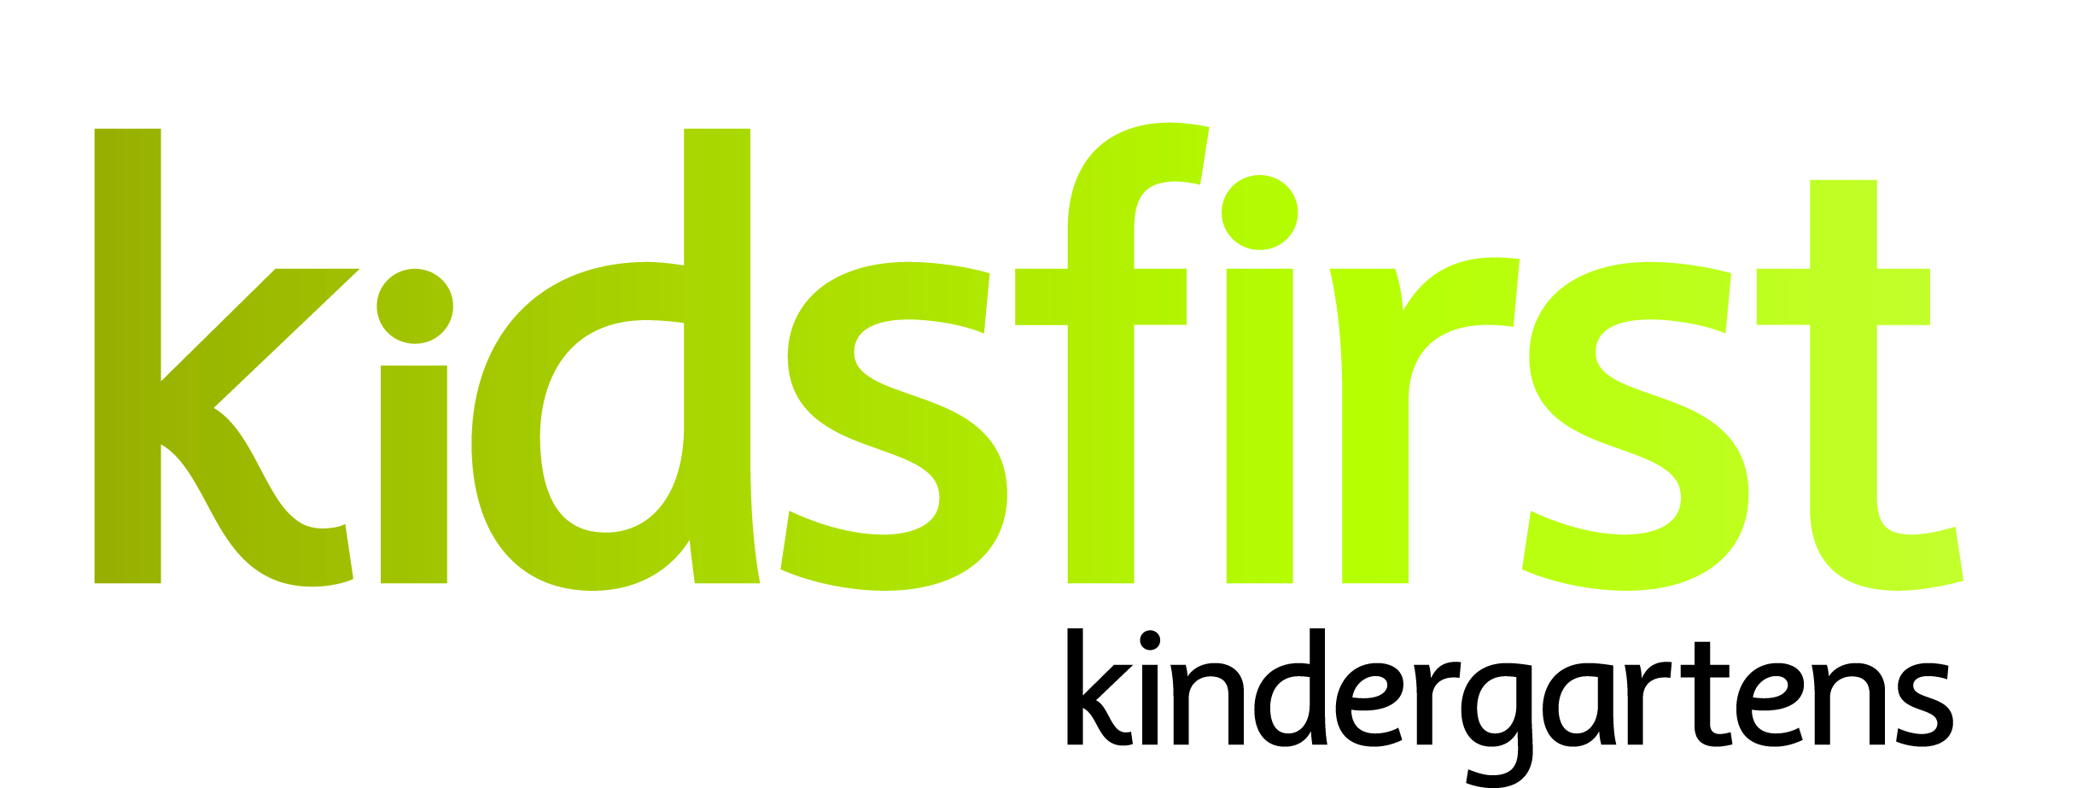

KINDERGARTEN AND PERSON SPECIFICATION

DATE: August 2019
POSITION: Relieving Teacher / Full Time
KINDERGARTEN: Kidsfirst Kindergartens Alexandra
ADDRESS: 3 Ventry Street, Alexandra
PHONE NUMBER: (03) 4488655
CURRENT OPERATING ROLL: All Day Kindergarten (8.45am to 2.45pm). Current roll 40/40

Description of community:
Kidsfirst Kindergartens Alexandra is one of seven kindergartens in the Central Otago area. The kindergarten is located in the community of Alexandra, beside Alexandra Primary School. The setting is purpose built with a spacious indoor area and an outdoor space that invites inquiry and exploration. The outdoor space is attractive and has undergone some re-development recently. This work is continuing.

Curriculum Emphases:
Kidsfirst Kindergartens Alexandra places emphasis on the importance of respectful collaborative relationships. The overarching emphasis in the curriculum encompasses the Māori values of:
- Whanaungatanga – relationships both with whānau, tamariki and the community
- Manaakitanga – care and respect
- Ako – learning together and from each other

Programme Priorities
- Being an intentional/purposeful teacher by providing inspiring environments, promoting a calm, respectful and peaceful environment and programme
- Building Tikanga Maori perspectives into the programme
- Children’s growing understanding of social competence, respect for self and others and taking responsibility within the programme
- Regular planning discussions linked to daily reflections and children’s individual learning goals
- In-depth Internal Evaluation focused on continuous improvement, informing teaching and learning practices

POSITION SPECIFICATIONS

The following derive from the Kidsfirst Kindergartens Areas of Practice Quality Evaluation Indicators (2014) which is available online http://assets2.kidsfirst.co.nz/assets/QEI-Poster.pdf.

Curriculum and teaching requirements

The successful applicant will be an intentional teacher who;
- Demonstrates understanding of the theoretical underpinnings of Te Whāriki
- Is committed to and participates in ongoing and appropriate professional development that informs and is reflected in their practice
- Participates in both child and teacher initiated sustained, shared teaching episodes to extend children’s thinking and value their contribution to the learning experience
- Is committed to their own understanding as a Treaty partner as demonstrated through professional growth and practice
- Has a commitment to and awareness of the principles of inclusion. This is evident in and integrated within their professional practice
- Uses robust pedagogical documentation to support assessment, planning for learning and self-review

Relationships with children

The successful applicant will;
- Value and respond to family/whānau aspirations for their children
- Value and respond to the social and cultural worlds and ways of learning of all children
- Provide feedback to children that acknowledges their effort and success
- Establish relationships and connections underpinned by kaupapa Māori /Māori pedagogy
- Be available to children so that they can revisit and share their learning with others

Community requirements

The successful applicant will;
- Have strong, responsive, reciprocal and respectful relationships with families/whānau, supporting children’s sense of belonging
- Be responsive to individual identities and learning complexities
- Demonstrate authentic partnerships with parents/whānau of all children
- Articulate and share the rationale for curriculum decisions with the kindergarten’s community of learners
- Transitions are supported by effective partnerships between family/whānau, services and schools
- Promote and encourage active participation, involvement and decision-making by the kindergarten community in all aspects of the teaching and learning programme and self-review
- Play an advocacy role to support the child and the family/whānau

Working as part of a teaching team

The successful applicant will;
- Seek and be responsive to professional feedback
- Have strong collaborative relationships and professional communication with colleagues
- Contribute to the team, providing an environment that reflects, and is responsive to the learners, whānau and wider learning community (people, places, and things, over time)

PERSON SPECIFICATION

Personal Attributes that would best suit the needs of the kindergarten:

- A team/relationship focused teacher who is creative, forward thinking, reflective and flexible in their approach.
- A teacher who has a working understanding of what an intentional/purposeful teacher looks like in practice.
- A teacher who has strong pedagogical practice that will support teaching and learners of 21st century learners
- A teacher who is able to support/foster inquiry learning with tamariki
- Has the ability to work in a busy kindergarten, be flexible and responsive to the programme
- A teacher with skills that will support her/him in building relationships and supporting families/whānau
- A teacher with a commitment to, and understanding of, bicultural practice
- A teacher with strengths in the principles of inclusion, social justice and a children’s rights approach
- Confidence and understanding of socio-cultural assessment for learning
- A teacher who is energetic, innovative, and enthusiastic, shows initiative and is able to articulate and listen to others points of view.
- A teacher who understands and can practice shared leadership within the team
- A teacher with strong ICT skills

