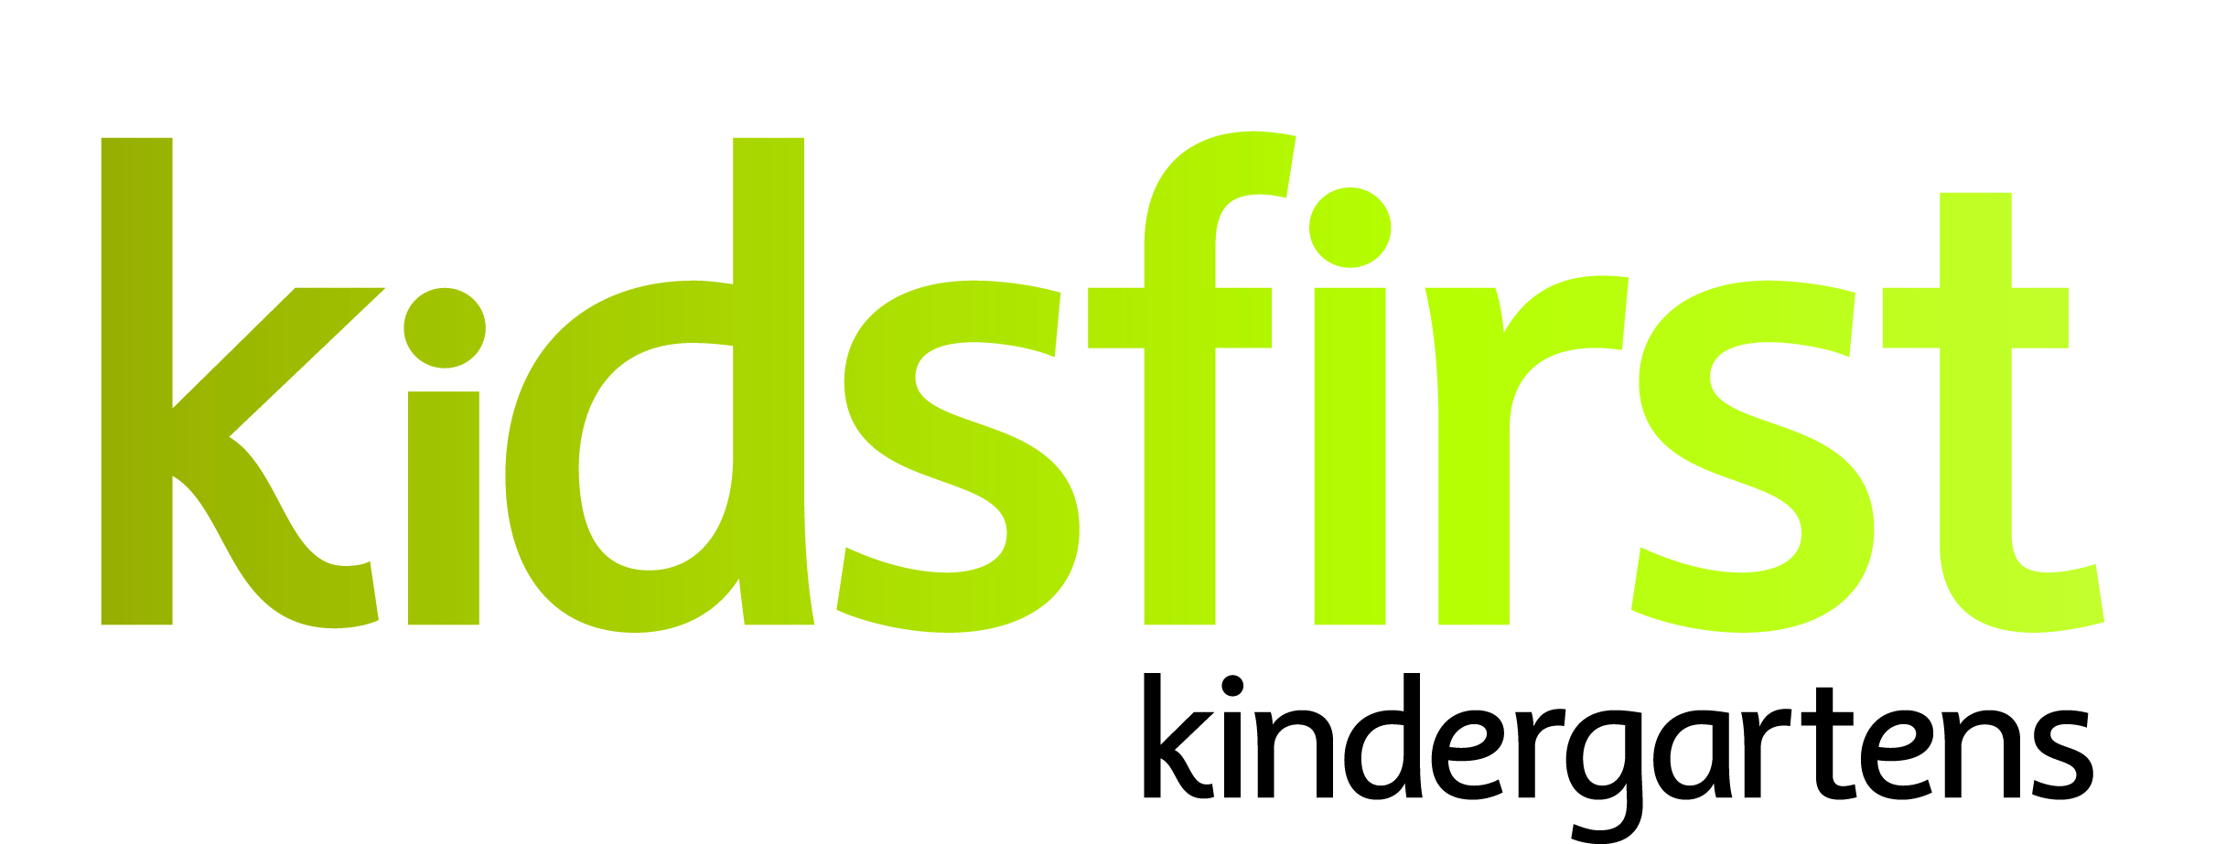
POSITION and PERSON SPECIFICATION
DATE: May 2024
POSITION: Kaiako (.727)
SERVICE: Kidsfirst Kindergartens Hornby
ADDRESS: 17 Brynley Street, Hornby, Christchurch
PHONE NUMBER: 021916070
CURRENT OPERATING ROLL: All Day Kindergarten (8.30am-2.30pm). Rolls currently operating at 30/30 Monday to Friday.

Description of and involvement in the community

Hornby Kindergarten has a long-standing history in the area having first opened in 1961. In 2017 the building underwent a complete transformation, creating a light, bright and welcoming space for tamariki and whānau. The indoor environment is spacious, well-resourced, and inviting. The outdoor area has a large, easy to supervise, big backyard with established gardens and trees that provide natural spaces for learning and play.

At the heart of this culturally diverse community belonging is a curriculum priority. There is a strong focus on language, culture, and identity. There are several Māori and Pasifika learners and whānau in the kindergarten and many other cultures represented. This provides a richness to the relationships within, whereby all cultures in the kindergarten are valued and celebrated.

The kindergarten supports and maintains connections in the community, including relationships with the two local schools enjoying being part of the wider local community. Whānau are engaged and supportive of the kindergarten. Kaiako value the pivotal role the whānau play in their child’s learning, seeking their aspirations and continued engagement in the programme.

Curriculum Priorities:
- Mana
- Confidence
- Identity
- Belonging

Curriculum Emphases:
- Culturally sustaining practice that supports the language culture and identity of tamariki and whānau
- Social and Emotional learning, with a strong focus on ‘Positive Behaviour Support’ strategies and implementation within the kindergarten
- Connections with whānau and the wider community networks
- Responsive and intentional teaching
- Inclusion and equity for all, identifying and breaking down barriers to support participation, achievement and belonging for all
- Planning to show tamariki progression over time, both individually and as a group
- Internal Evaluation that supports growth and positive learning outcomes

Job Description
The following derive from the Kidsfirst Kindergartens Areas of Practice Quality Evaluation Indicators

Curriculum and teaching requirements

The successful applicant will be an intentional Kaiako who:
- Demonstrates understanding of the theoretical underpinnings of Te Whāriki
- Participates in ongoing and appropriate professional development that informs and is reflected in their practice
- Participates in both tamariki and kaiako initiated, sustained shared teaching episodes to extend tamariki thinking and value their contribution to the learning experience
- Is committed to their own understanding as a Treaty partner as demonstrated through professional growth and practice
- Has a commitment to and awareness of the principles of inclusion. This is evident in and integrated within their professional practice
- Uses robust pedagogical documentation to support assessment, planning for learning and internal evaluation, improving learning outcomes for tamariki.

Relationships with children

The successful applicant will:
- Value and respond to family/whānau aspirations for their tamariki
- Value and respond to the social and cultural worlds and ways of learning of all tamariki
- Provide feedback to tamariki that acknowledges their effort and success
- Establish relationships and connections underpinned by kaupapa Māori /Māori pedagogy

Community requirements

The successful applicant will:
- Have strong, responsive, reciprocal, and respectful relationships with whānau supporting tamariki and their sense of belonging
- Be responsive to individual identities and learning complexities
- Articulate and share the rationale for curriculum decisions with the kindergarten’s community of learners.
- Demonstrate authentic partnerships with parents/whānau of all tamariki
- Promote and encourage active participation, involvement, and decision-making by the kindergarten community in all aspects of the teaching and learning programme and internal evaluation
- Play an advocacy role to support tamariki and the whānau.

Working as part of a teaching team

The successful applicant will:
- Seek and be responsive to professional feedback
- Have strong collaborative relationships and professional communication with colleagues
- Contribute to the team, providing an environment that reflects, and is responsive to the learners, whānau and wider learning community (people, places, and things, over time).

PERSON SPECIFICATIONS

Personal Attributes that would best suit the needs of the centre:
- A committed partner to Te Titiriti o Waitangi with a commitment to, and understanding of, bicultural practice
- An intentional kaiako with a proven approach to supporting children’s learning outcomes and an excellent working knowledge of Te Whāriki
- A team/relationship focused kaiako who is creative, forward thinking, reflective and flexible in their approach.
- A kaiako who understands infant and toddler pedagogy
- A kaiako with skills that will support her/him in building relationships and supporting whānau
- A kaiako who can be an advocate for tamariki, and who can work professionally with external agencies, as required
- A kaiako with strengths in the principles of inclusion and social justice
- Confidence and understanding of socio-cultural assessment for learning
- A kaiako who is energetic, enthusiastic and shows initiative
- A kaiako who can work confidently and effectively in a small team.

